**INTRODUCTION**

**1.1OVERVIEW**

**1.The world has changed as a consequence of the increasing use of smartphones, which have improved communication, connected people, and revolutionized many different businesses.**

**2. In order to shed light on important factors like market penetration, customer preferences, economic ramifications, and societal changes, this research report will perform a data-driven investigation of the impact of the iPhone in India.**

**1.2 PURPOSE**

**1.Overall, Apple's history in India is a testament to the company's ability to adapt to new markets and invest in new technologies.**

**2.iPhone is a line of smartphones produced by Apple Inc. that use Apple's own iOS mobile operating system**.

**2.problem definition & design thinking**

**2.1 empathy map**

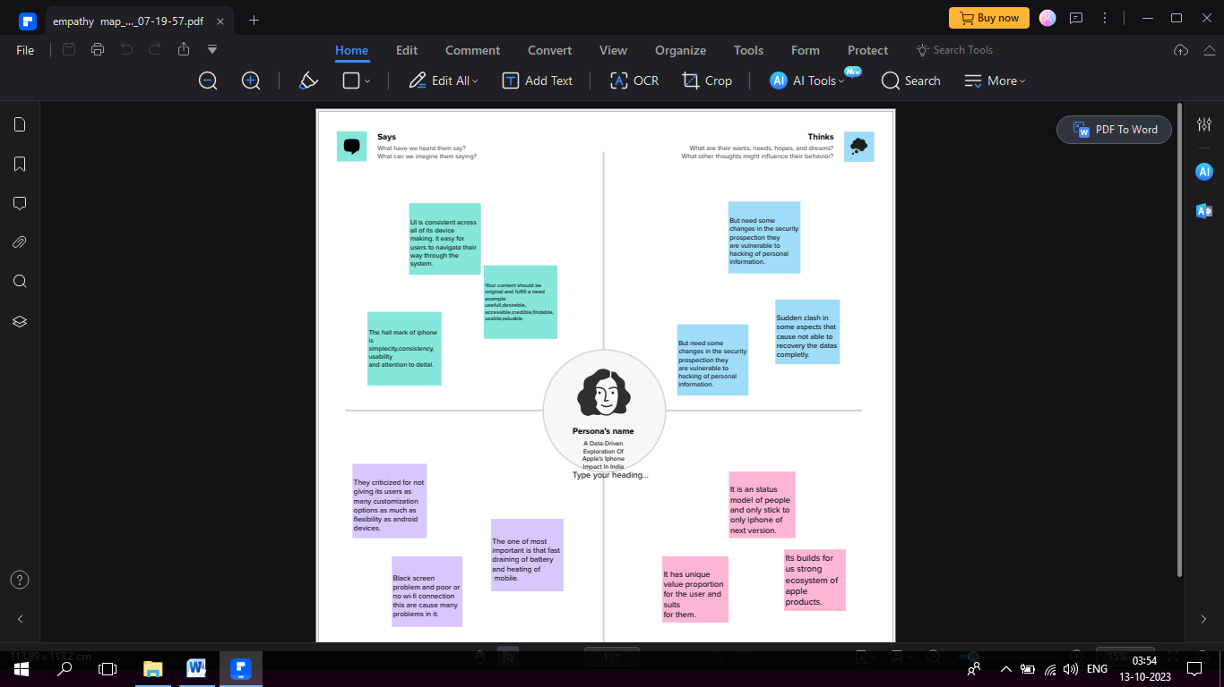

2.2 IDEATION& BRAINSTROMING MAP

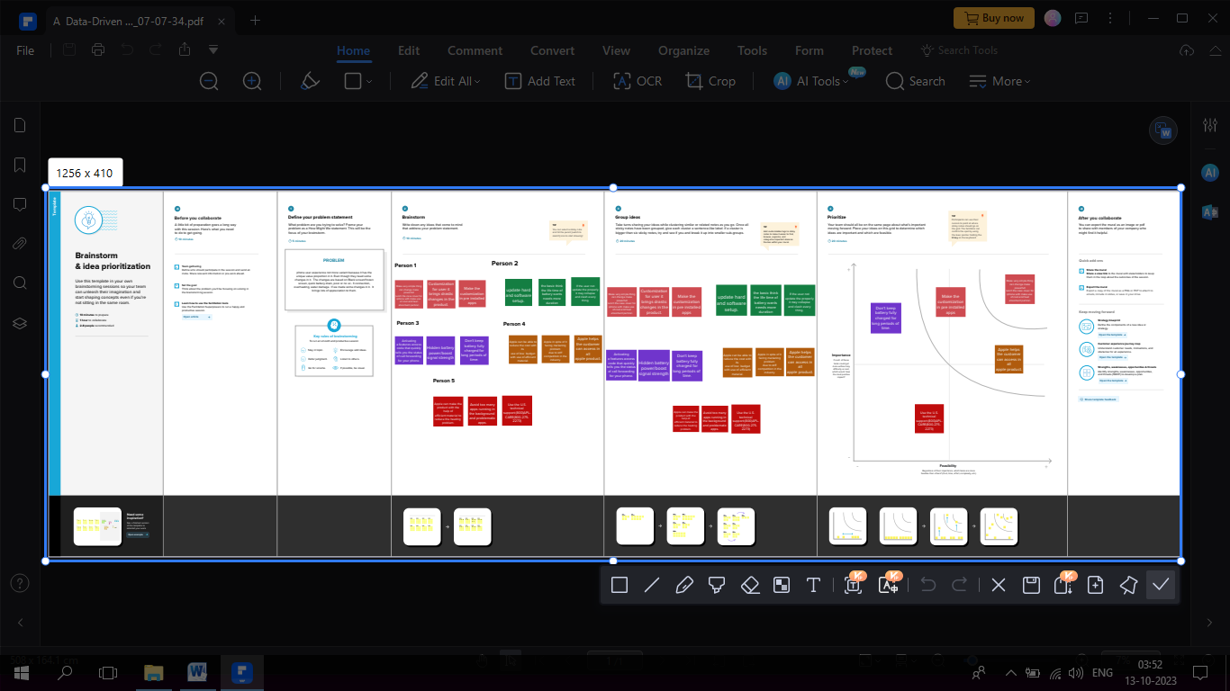

**3. RESULT**

**1.The opening of Apple's own stores in Mumbai and New Delhi symbolises India's arrival in the big league of economies.**

**2. Apple Inc. assembled more than $7 billion of iPhones in India last fiscal year, tripling production in the world's fastest-growing smartphone.**

**4.Advantages**

**1. Apple products have driven the creation of new markets and lifestyle habits.**

**2.Apple's target audience consists of middle-class and upper-class users who can pay higher for products that provide them with an incredible user .**

**Disadvantages**

1. **APPLE'S SUPPLY CHAIN​​ Quality problems are identified in the manufacturing gap related to design, which can be overcome.**

1. **India is a massive market with an expanding middle class to power sales growth, and potentially a home base for the production of millions reduced.**

**5.APPLICATIONS**

**1.** **Led by a surge in smartphone sales, the application or app market in the country is likely to grow by more than four times to $ 626.23.**

**2. India has emerged as a key strategic market for Apple over the last few years. ... revolution comes to India: First store opens on April 18.**

**6.CONCLUSION**

**1.This market case study aims to determine how Apple can target such opportunities to help predict future trends and influences over the market.**

**2. At the time of the announcement this innovative feature set the. iPhone apart from the competition in the wireless-phone market.**